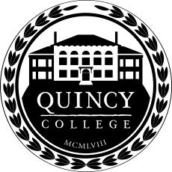

Quincy College Board of Governors
Shall meet on

Thursday, April 16th, 2026 at 4:00 p.m.

Quincy College 7th Floor Conference Center 1250 Hancock Street, Quincy & Remotely via Zoom
Public Access via Zoom Only

https://quincycollege.zoom.us/meeting/register/lKPN5W_rQUyWxvcoEzTTBg
Meeting ID: 878 6821 1360
Passcode: 094738

Register in advance for this meeting. After registering, you will receive a confirmation email containing information about joining the meeting.

AGENDA

The listings of matters are those reasonably anticipated by the Chair which may be discussed at the meeting. Not all items listed may in fact be discussed and other items not listed may also be brought up for discussion to the extent permitted by law.
- Call to Order

- Pledge of Allegiance & Moment of Silence

- Open Forum*

- Chairman’s Report

- President’s Report
  - Budget and Investments
  - Allied Health
  - RN to BSN
  - NECHE Update
  - Summer Enrollment Update
- Old Business
  - Approval of Full Board Meeting Minutes
  - Strategic Plan Committee Meeting Minutes Approval
- New Business
- Adjournment

*Pursuant to the provisions of Article II, Section 7 of the By-Laws of the Quincy College Board of Governors, anyone wishing to address the Board of Governors during the Open Forum must notify the Board of his/her intention to do so in writing, by regular mail, electronic mail, or in hand to the Office of the President not less than 48 hours prior to the posted start time of the meeting.

